Numerical Inversion of Laplace Transforms in Matlab

Inversion of Laplace transforms is a very important procedure used in solution of complex linear systems.
The function f(t)=INVLAP(F(s)) offers a simple, effective and reasonably accurate way to achieve the result. It is based on the paper:
J. Valsa and L. Brancik: Approximate Formulae for Numerical Inversion of Laplace Transforms, Int. Journal of Numerical Modelling: Electronic Networks, Devices and Fields, Vol. 11, (1998), pp. 153-166
The transform F(s) may be any reasonable function of complex variable s^α, where α is an integer or non-integer real exponent. Thus, the function INVLAP can solve even fractional problems and invert functions F(s) containing rational, irrational or transcendental expressions.
The function does not require to compute poles nor zeroes of F(s). It is based on values of F(s) for selected complex values of the independent variable s. The resultant computational error can be held arbitrarily low at the cost of CPU time. With the today’s computers and their speed this does not present any serious limitation (see Examples).

% INVLAP – Numerical Inversion of Laplace Transforms
function [radt,ft]=INVLAP(Fs,tini,tend,nnt,a,ns,nd);
% Fs is formula for F(s) as a string
% tini, tend are limits of the solution interval
% nnt is total number of time instants
% a, ns, nd are parameters of the method
% if not given, the method uses implicit values a=6, ns=20, nd=19
% it is recommended to preserve a=6
% increasing ns and nd leads to lower error
% an example of function calling
% [t,ft]=INVLAP('s/(s^2+4*pi^2)',0,10,1001);
% to plot the graph of results write plot(t,ft), grid on, zoom on
FF=strrep(strrep(strrep(Fs,'*','.*'),'/','./'),'^','.^');
if nargin==4
a=6; ns=20; nd=19; end; % implicit parameters
radt=linspace(tini,tend,nnt); % time vector
if tini==0 radt=radt(2:1:nnt); end; % t=0 is not allowed
tic % measure the CPU time
for n=1:ns+1+nd % prepare necessary coefficients
alfa(n)=a+(n-1)*pi*j;
beta(n)=-exp(a)*(-1)^n;
end;
n=1:nd;
bdif=fliplr(cumsum(gamma(nd+1)./gamma(nd+2-n)./gamma(n)))./2^nd;
beta(ns+2:ns+1+nd)=beta(ns+2:ns+1+nd).*bdif;
beta(1)=beta(1)/2;
for kt=1:nnt % cycle for time t
tt=radt(kt);
s=alfa/tt; % complex frequency s
bt=beta/tt;
btF=bt.*eval(FF); % functional value F(s)
ft(kt)=sum(real(btF)); % original f(tt)
end;
toc

Examples of inversion of some typical transforms

% example_1 - inversion of an irrational fraction F(s)
clear, close all
[t1,ft1]=INVLAP('tanh(s)/s',0.01,20,1000);
[t2,ft2]=INVLAP('tanh(s)/s',0.01,20,2000,6,280,59);
figure(3)
set(3,'color','white')
subplot(2,1,1)
plot(t1,ft1), grid on, zoom on
xlabel('t [s]'), ylabel('f(t)')
title('rectangular periodic wave')
subplot(2,1,2)
plot(t2,ft2), grid on, zoom on
xlabel('t [s]'), ylabel('f(t)')
title('improved accuracy')

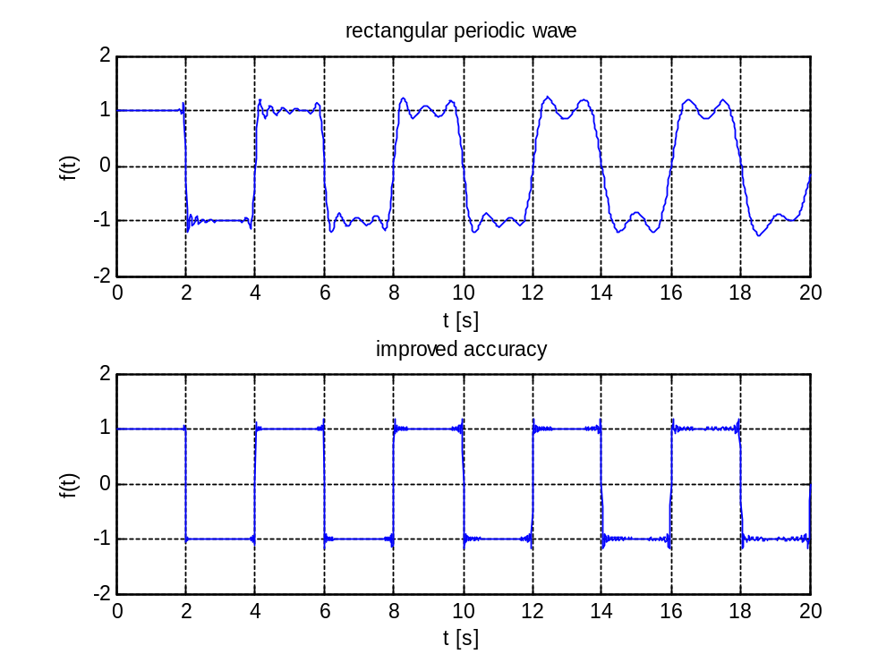

% example_2 - inversion of a fractional F(s)
clear, close all
[t1,ft1]=INVLAP('1/(sqrt(s)*s)',0.01,5,200,6,40,20);
[t2,ft2]=INVLAP('(20.5+3.7343*s^1.15)/(21.5+3.7343*s^1.15+0.8*s^2.2+0.5*s^0.9)/s',0.01,5,200);
figure(4)
set(4,'color','white')
subplot(2,1,1)
plot(t1,ft1), grid on, zoom on
xlabel('t [s]'), ylabel('f(t)')
%title('
subplot(2,1,2)
plot(t2,ft2), grid on, zoom
xlabel('t [s]'), ylabel('f(t)')
title('step response of a fractional control system')

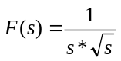
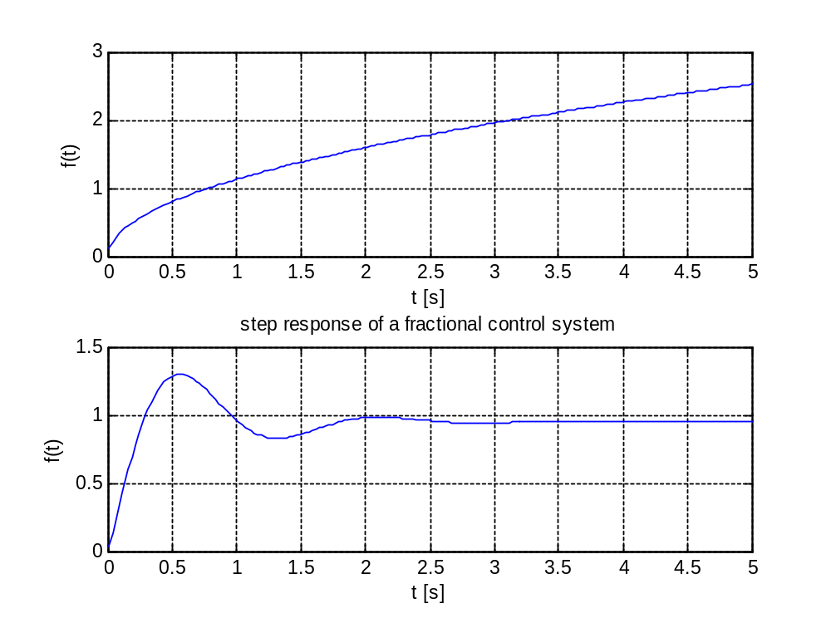

% example_3 - inversion of a fractional F(s) in symbolic form
clear, close all
syms D1 alfa1 R1 s
% parameters of the network with constant phase element
I=0.25; Rs=0.1; R1=100; D1=1; alfa1=-0.7;
% F(s) in symbolic form
F1=I*(Rs+(R1*D1*s^alfa1/(R1+D1*s^alfa1)))*(1-exp(-4000*s))/s;
% F(s) as a string
F1=char(F1);
% parameters of the fractional control system
k=20.5; a1=3.7343; alfa1=1.15; a2=0.8; alfa2=2.2; a3=0.5; alfa3=0.9;
F2=(k+a1*s^alfa1)/(k+1+a1*s^alfa1+a2*s^alfa2+a3*s^alfa3)/s; % F(s) in symbolic form
F2=char(F2); % F(s) as a string
[t1,ft1]=INVLAP(F1,0.01,1e4,1000,6,39,89);
[t2,ft2]=INVLAP(F2,0.01,5,200);
figure(5)
set(5,'color','white')
subplot(2,1,1)
plot(t1,ft1), grid on, zoom on
xlabel('t [s]'), ylabel('f(t)')
title('response to the input current impulse')
subplot(2,1,2)
plot(t2,ft2), grid on, zoom
xlabel('t [s]'), ylabel('f(t)')
title('step response of a fractional control system')
